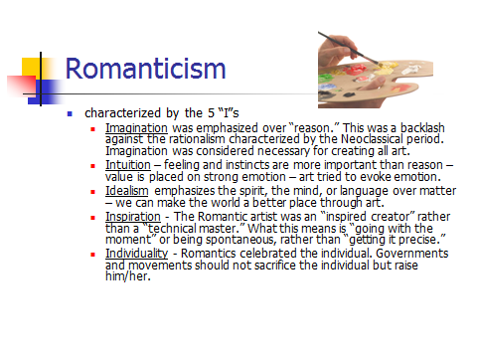Revolution in the Arts Reflection

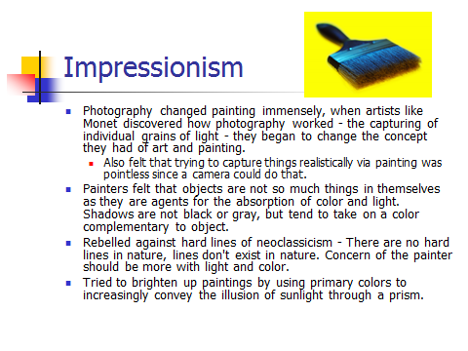

1. 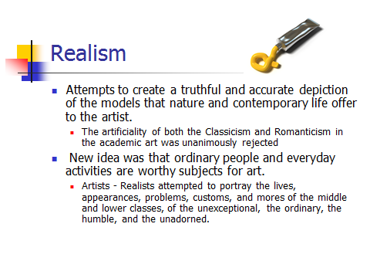What was the key element in Romanticism?
2. What was the goal of Impressionist painters?
3. How are the movements of Romanticism and Realism similar? How are they different?
4. How could a realist novel bring about changes in society? What are some examples?
5. How did Nationalism affect Romanticism and the other artistic movements of this time?