POLITICAL CARTOON ANALYSIS

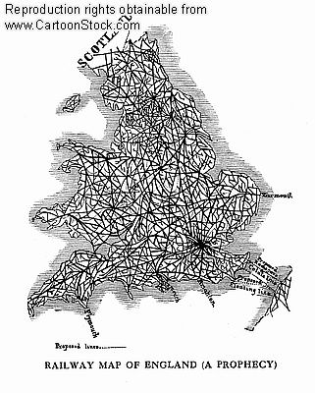

- What issue is this political cartoon about?

- What is the cartoonist’s opinion on this issue?

- What other opinion can you imagine another person having on this issue?

- Did you find this cartoon persuasive? Why or why not?

- What other techniques could the cartoonist have used to make this cartoon more persuasive?

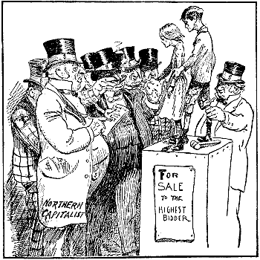

- What issue is this political cartoon about?

- What is the cartoonist’s opinion on this issue?

- What other opinion can you imagine another person having on this issue?

- Did you find this cartoon persuasive? Why or why not?

- What other techniques could the cartoonist have used to make this cartoon more persuasive?

