INDUSTRIAL REVOLUTION DBQ

Directions: The following question is based on the accompanying Documents 1 – 12. (The documents have been edited for the purpose of this exercise.) This question is designed to test your ability to work with and understand historical documents. Write an essay that:
• Has a relevant thesis and supports that thesis with evidence from the documents.
• Uses all of the documents.
• Analyzes the documents by grouping them in as many appropriate ways as possible. Does not simply summarize the documents individually.
• Takes into account both the sources of the documents and the authors’ point of view.
• Explains the need for one type of additional document.

You may refer to relevant historical information not mentioned in the documents.

Question: Evaluate the positive and negative effects of the Industrial Revolution.

Document 1
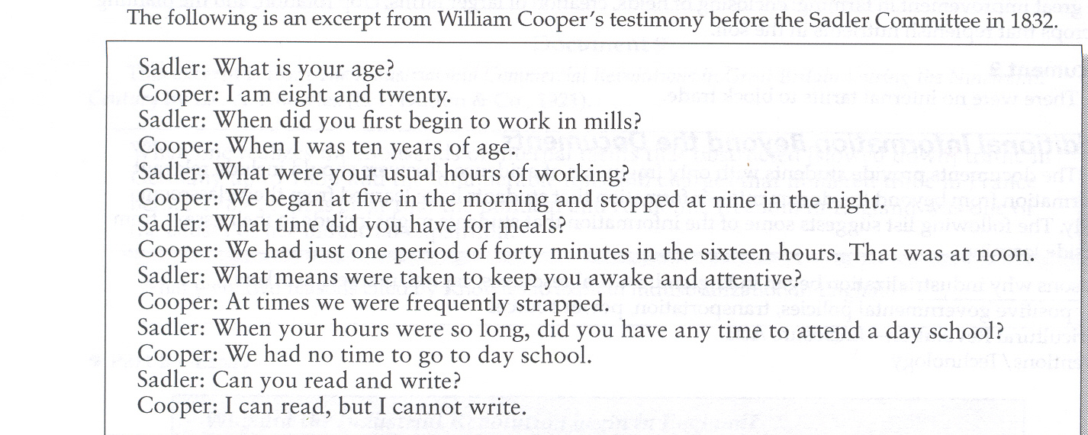

Document 2
“Contrary to the vulgar belief that men are motivated primarily by materialistic considerations, we now see the capitalist system being discredited and destroyed all over the world, even though this system has given men the greatest material comforts”
Ayn Rand (Russian born American Writer and Novelist, 1905-1982)

Document 3
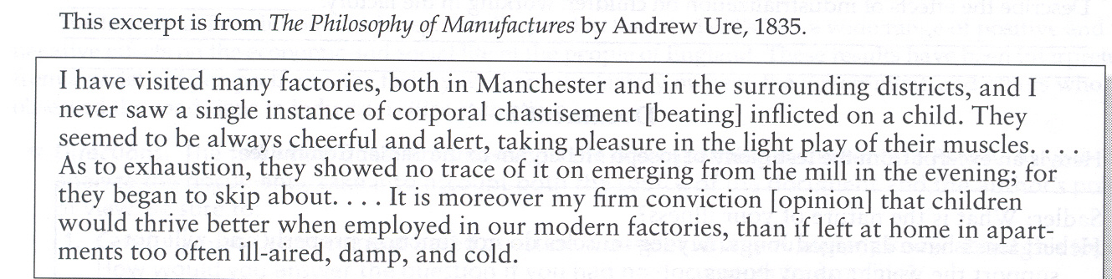

Document 4
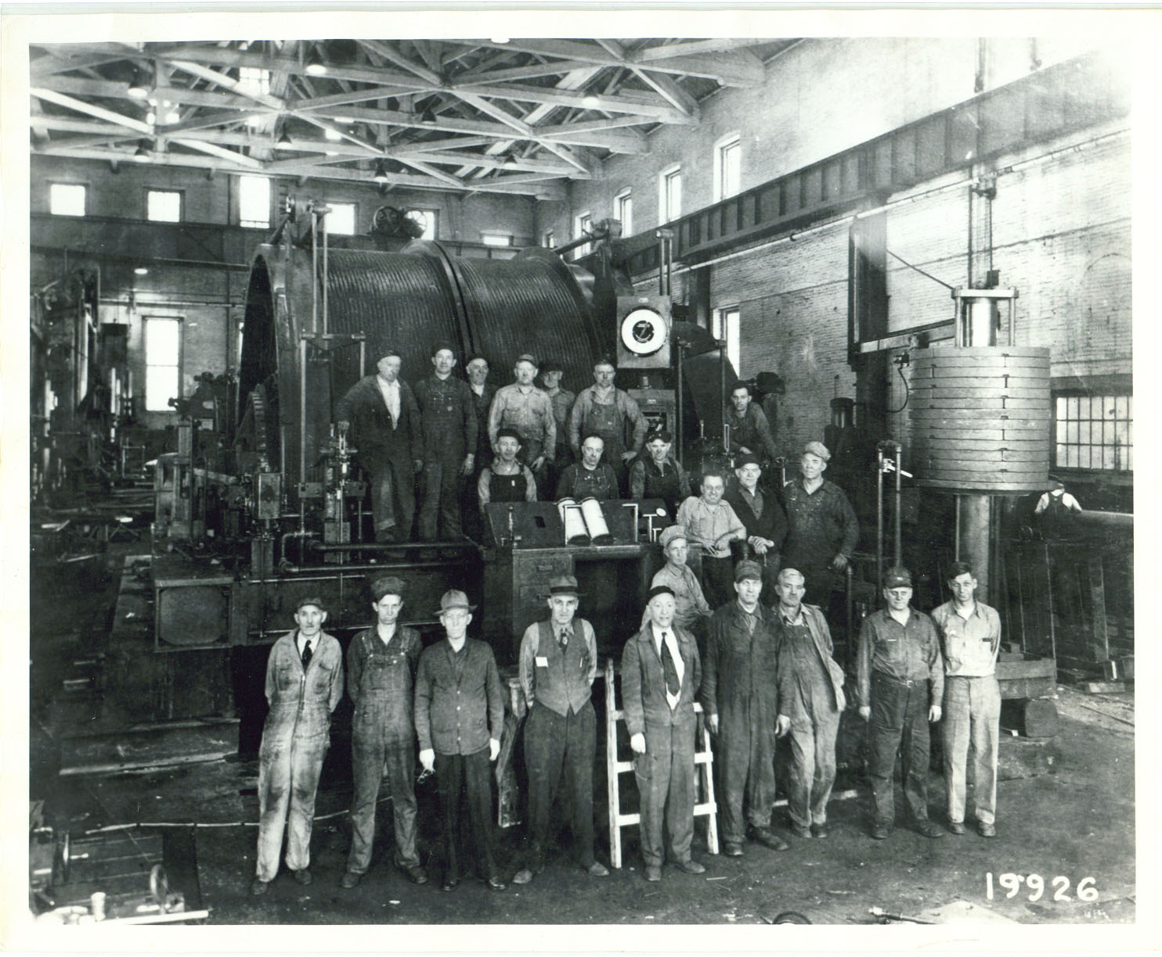

Document 5
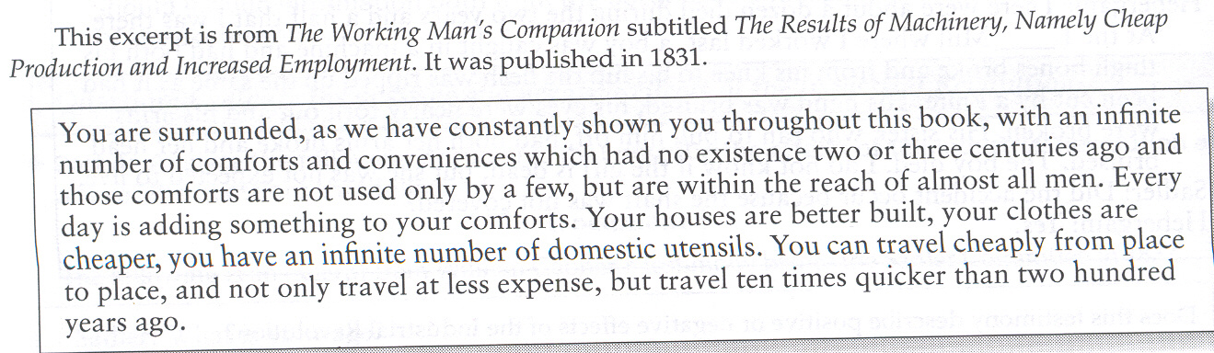

Document 6
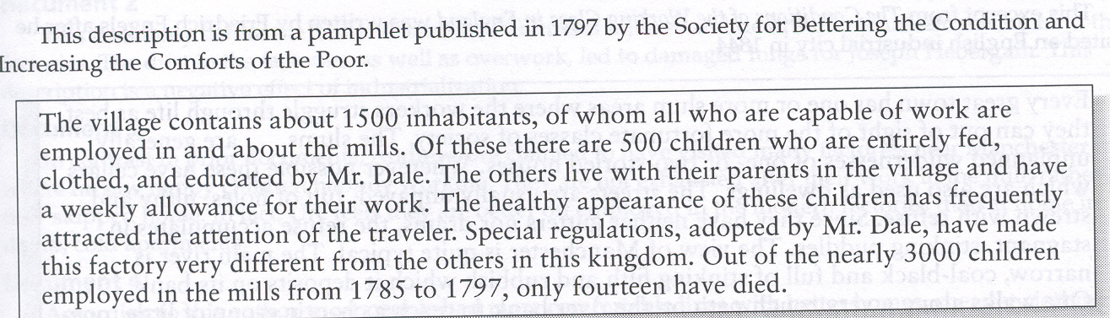

Document 7
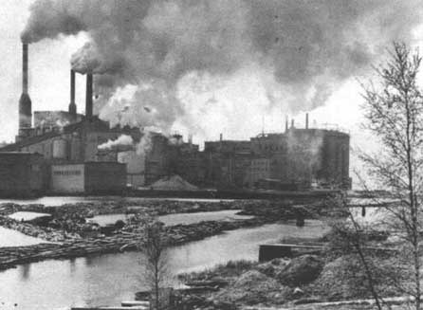

Document 8
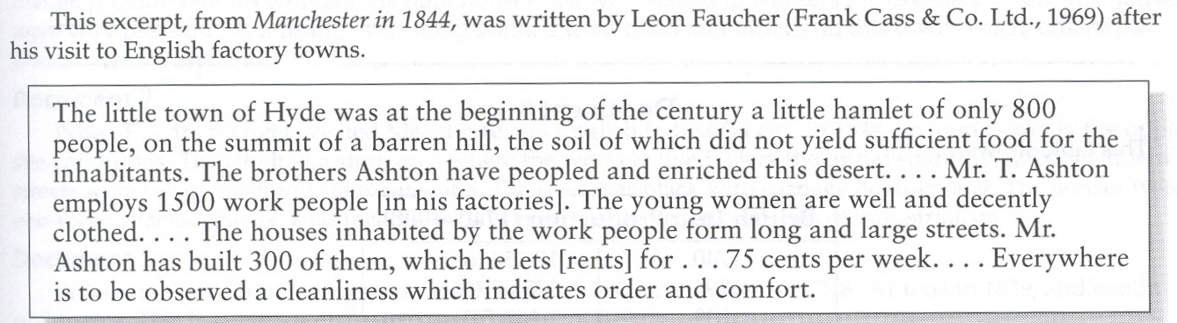

Document 9
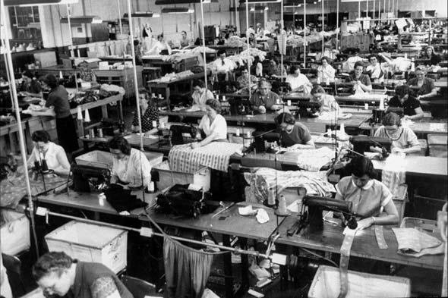

Document 10
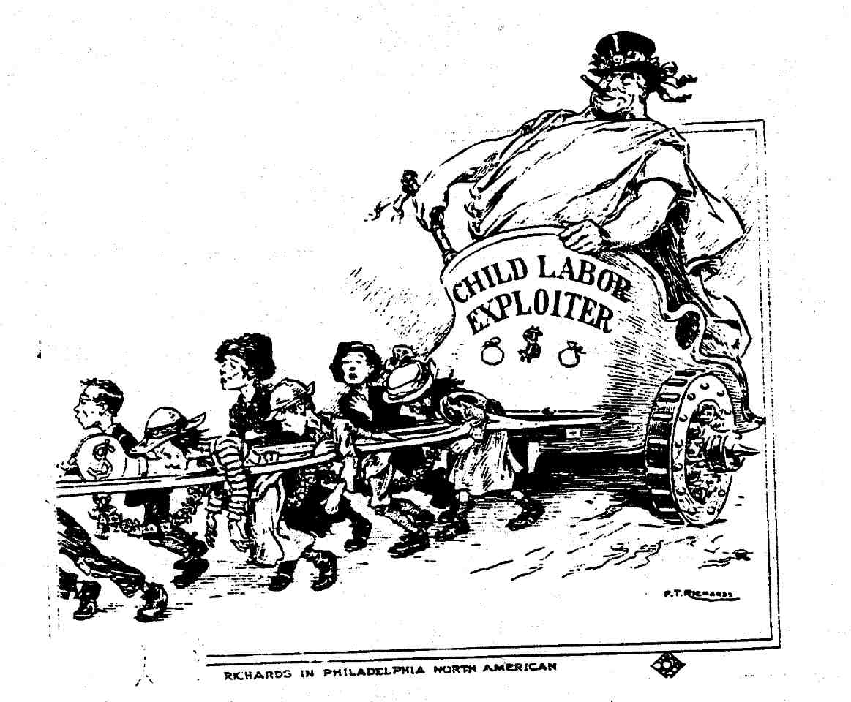

Document 11
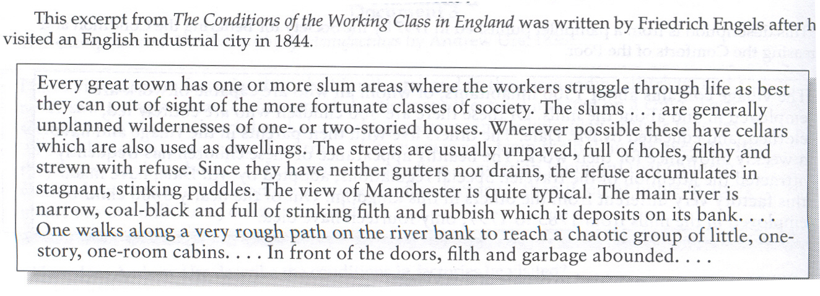

Document 12
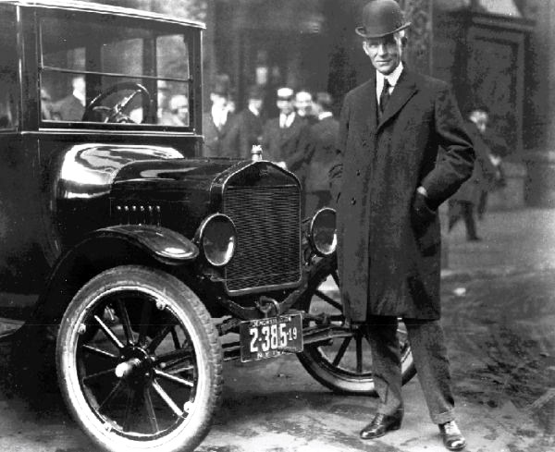

Document 13
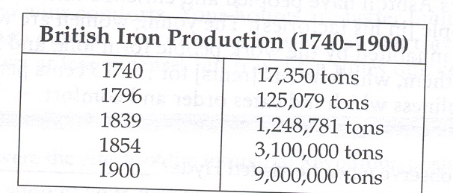

Document 14
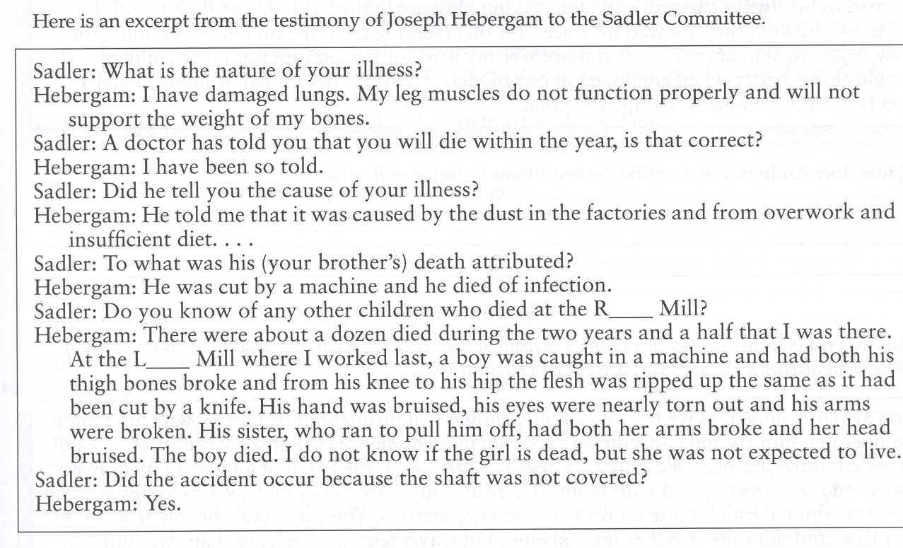

Document 15
